Employee Database Management System
Making of database management system with the help of database and python

7/19/2019

BY Mustain Billah and Arpan Kumar Pramanik

Under guidance of Subhadeep Chakraborty

Table of content

1. Introduction
2. Software used
3. How to use the system
4. Output
6. Conclusion

Introduction:
This is a Simple Employee Database System made with python GUI and SQLlite database software. In that system the user can entry the data about the employees ,The entry field will appear after clicking New entry button, there is also a delete button to delete the entries. A output will be shown to the user as a gui output and the data will store at the main database. we choose the python language as it is easier than java .
With this system we can easily enter data to our database.

Software Used:
- We have used python 3.7.4 version to make the gui.
Inside the code at python we have used the tkinter package to make the gui.

- We have use sqlLite which we have used as database.

How to use:

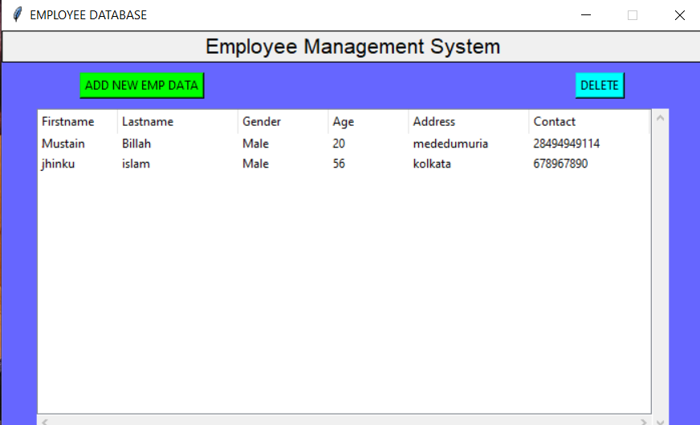

After appearing this above GUI if we click on the “ADD NEW EMP DATA” a new gui will appear to take the information like this. we can insert value here.
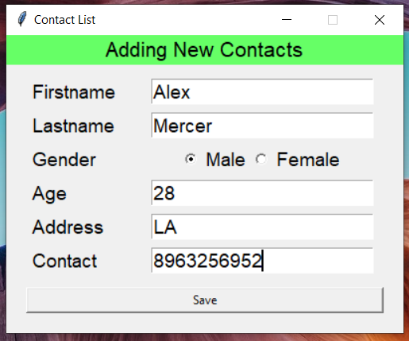
The input field

Output:

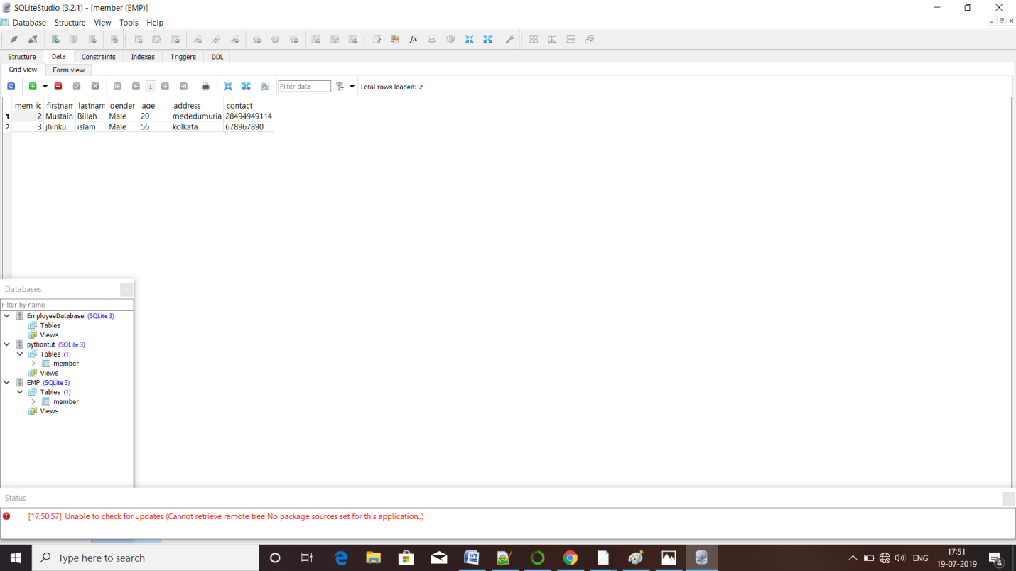
After entering the data to the database the database will look like this.

Conclusion:
We gain a lot of ideas and knowledge after doing this project. For the purpose of the project we came to know about the database connectivity with python. We got a lot help from our respected sir, he helped us to the project in the right way. We have also collected data from internet,
We hope the idea, codes and the methods of the project will help us to make other projects in future.

